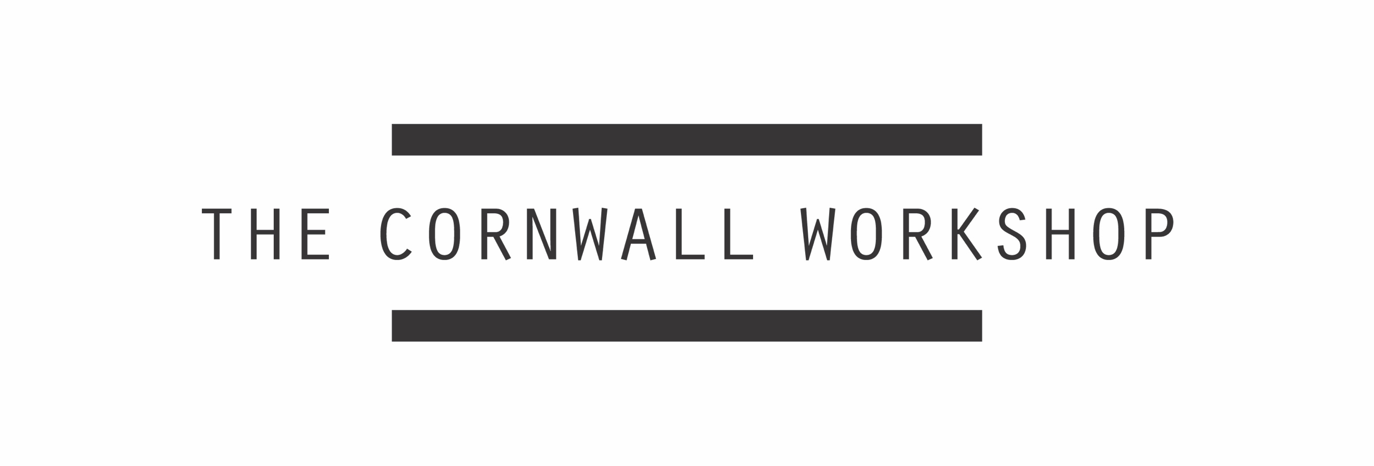

APPLICATION FORM 2017

First name:
Surname:
Date of birth:
Address:

Town/City:
Postcode:
Tel:
Email:
Website address if applicable:
Dietary requirements:

Access requirements:

How did you hear about The Cornwall Workshop?

Educational background and CV:

Please include a copy of your CV with your application as an email attachment.

Please provide a brief description of your current practice
(max 400 words):

We hope that the workshop led by Christina Mackie will generate ‘wanderings and conversations’ that can be shared on the Groundwork website and contribute to the development of the Groundwork programme.

What experience or knowledge could you bring to the workshop? (Don’t discount things you do or know that are separate to your work as an artist) (max 250 words):

Please write a short description of a work of art, exhibition or event you have particularly enjoyed in the last year (500 words max):

/End

