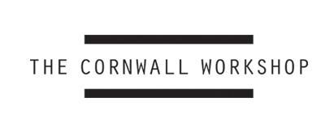
KESTLE BARTON, 13 TO 20 MARCH 2026
www.thecornwallworkshop.com

APPLICATION FORM

First name:
Surname:
Date of birth:
Address:
Town/City:
Postcode:
Tel:
Email:
Website address if applicable:
Dietary requirements:
Access requirements:
How did you hear about The Cornwall Workshop?
Educational background and CV:
Please include a copy of your CV with your application as an email attachment or a link to your website.

Please provide a brief description of your current practice
(max 250 words):
The 2026 workshop will offer a space in which to explore a range of ideas suggested by Ane Hjort Guttu’s interests and work.

Ane Hjort Guttu is a filmmaker, visual artist and curator based in Oslo. She works in a variety of media, but has in recent years mainly concentrated on film and video works, ranging from investigative documentary to poetic fiction and exploring issues of power and freedom in the Scandinavian post-welfare state.

What interests you about Ane Hjort Guttu’s work and the opportunity to be part of this workshop. As part of your response please consider what knowledge or experience you could contribute - or would hope to develop – through your participation in the workshop? (max 250 words):

/Continued

Please write a short description of a work of art, text, exhibition, screening or event you have particularly enjoyed in the last year (500 words max).

/End

